Action Planning Worksheet: G-WAVE
Step #1: Articulate your S.M.A.R.T Goal:
Step #2  WHY is the goal important to you?  Step #5 | 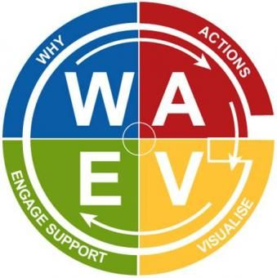 | Step #3  What ACTIONS do you need to take?  Step #4
Who do you need to ENGAGE for support and help in accomplishing your goal? |  | VISUALIZE: What will the outcomes look like?
Getting Started-Taking Action
- Goal:
Specific | Measurable | Action Oriented | Realistic | Time Bound
- WHY is the goal important to you? What is the purpose behind the goal?
- What ACTIONS do you need to take?
- VISUALIZE: What will the outcomes look like?
- Who do you need to ENGAGE for support and help in accomplishing your goal?
Notes:

